Tutorial

Thug x4

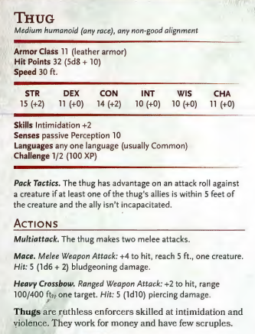

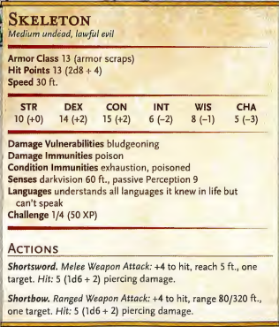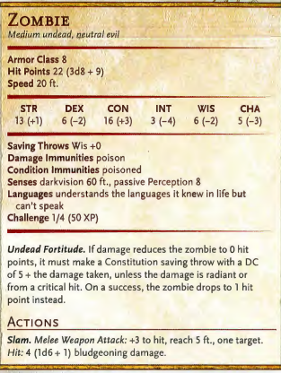City walls

Zombie x6, skeleton x3, ogre x1 vs veteran x1, guardsman x2

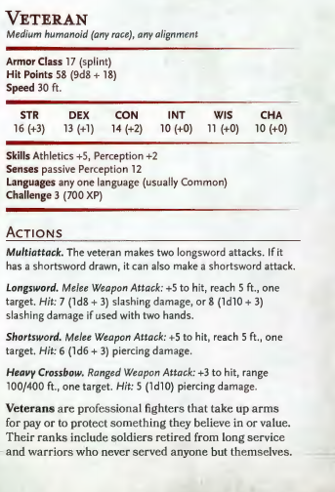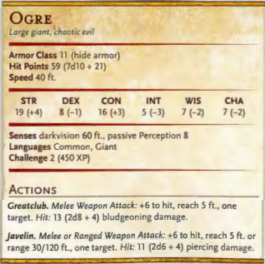

In town:

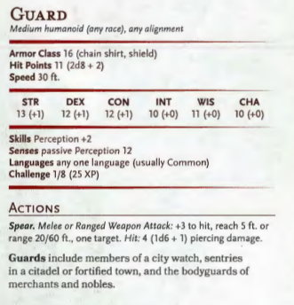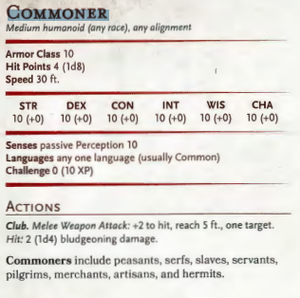

Alleyway:

8x kenku

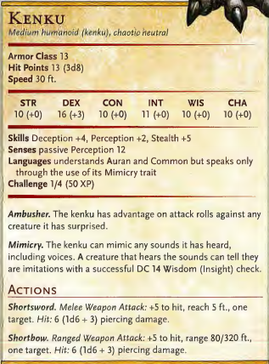

Farmhouse:

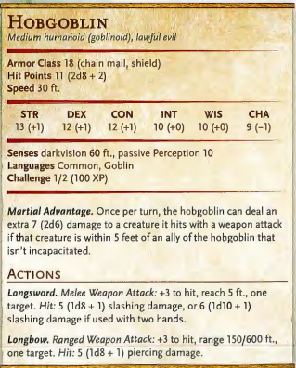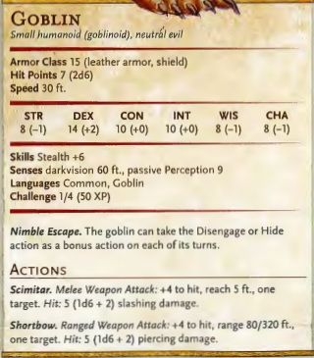Goblins x 6, hobgoblins x 3

300 + 300 = 600 x 2.5 = 1500

Hobgoblins attack elves first, move in warbands, expect tactical combat, use of cover etc, martial advantage when they fight in packs, DARKVISION, weapons

For the master!

Scrubland: in charred fields etc +5 to stealth/-5 to goblin/hob perception rolls

Light:

Forest encounter:

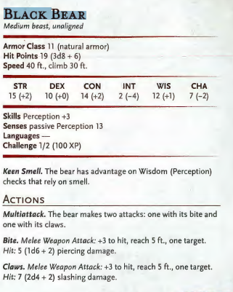Black bear x4

400 x 2 = 800

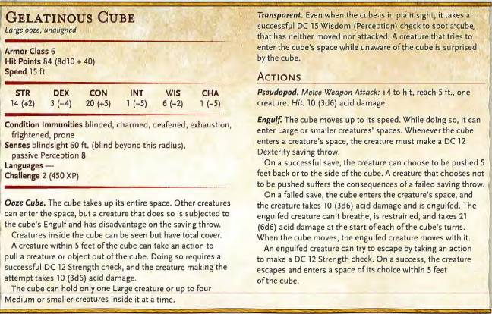Hall of traps:

Traps:

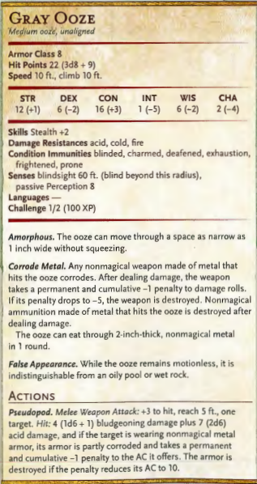Arrow trap – 2d6 piercing damage | pendulum trap – 4d6 slashing damage, knocked prone 3 squares away (swings on d6 – 6) | fire trap – 2d8 fire damage

Five segments:

Bridge width: 12 squares + one either side for bridge wall – damaged in places – rubble

First segment: 9 squares - Piles of bones, general detritus, barrels etc scattered around

2x dart trap statues, one blade trap – blade swings on a d6 5,6 DC 15 (perception) to spot pressure plates for arrow traps, DC 18 (perception) to spot score marks from blades, same DCs but vs survival to recognise what they are

Three zombies wandering area, three skeletons arise from piles of bones around area

Separator: Large pile of rubble, takes a full two turns to climb over

Second segment: 11 squares - general detritus, barrels, bridge has fallen away at one end leaving gap into the abyss – 2x statues (flame traps) either side of bridge, plate causes flames to shoot out into a 4x4 area in centre of bridge – DC10 to spot scorch marks

3x gray ooze underneath piles of rubble – if party passes within 2 squares of a pile the ooze emerges and attacks

Separator: gap three squares wide at thinnest point. If party searches they find sufficient boards to bridge gap – otherwise can jump over

Third segment – 18 squares – ruined guard houses halfway down bridge (6x6x6) containing hobgoblin archers and 1 leader – sufficient cover (boxes etc) to get up on guard houses

Loaded crane with barrels etc in a net hangs above near of the gatehouses

On one side is a thief scrawl indicating the presence of a control panel behind a box – if used can reposition the crane above a gatehouse and release the boxes (two turns)

Or Jenkins can shoot out rope (rope AC 19, 10hp)

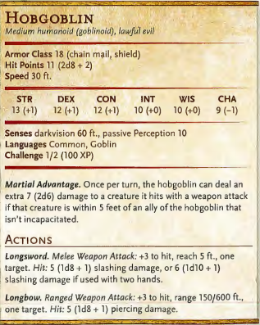Hobgoblins x 5 = 500 x 2 = 1000

Separator: Collapsed crane, 10foot wooden beams make up crane, completely blocks bridge and needs to be climbed over

Fourth segment – 14 squares – no detritus/rubble at all, floor seems swept clean. No bones, no wood, nothing – 2 x statues (DC 12 to see they look damaged)

1 x pendulum trap (behind ooze)

Gelatinous cube sits in the middle – doesn’t move until PC gets close to it then moves to engulf

Separator – large barricades of carved, sharpened wood, takes time to climb over

Fifth segment – last segment of bridge into landing area on other side, barricades, supplies, sandbags, weapon racks (to replace damaged weapons from before), large door off bridge. Two statues at end of bridge next to door

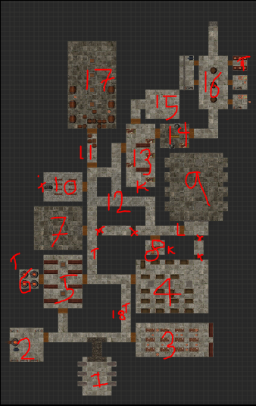Drakenhof dungeon:

General:

Stone flags, torches in sconses on walls at irregular intervals – light enough to see, but dim, shadows everywhere. Ceiling around 10-12ft high, draped in spiderwebs. Constant sound of chittering within the webs, and you can occasionally see movement as the webs bulge and shudder.

1. Crypt

Three coffins either side, three of which are still sealed, the others broken open.

If opened – one has golden cutlery worth 5gp

One has a skeleton warrior who attacks the party

One is completely empty

1. Armoury

Several workbenches and benches around the room, as well as weapon racks on the walls. The weapons are standard, nothing special – swords, pikes, spears etc.

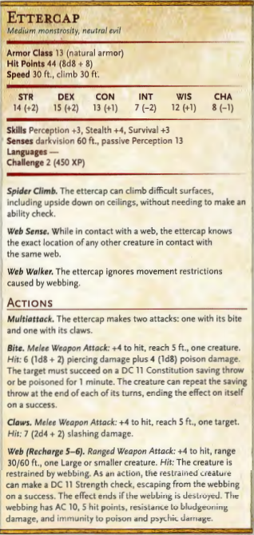DC 10 perception – a pickaxe

1 ettercap in room and 2 spiders behind

3x arrows +1, 1x potion of healing on tables

450 + 100 = 550 x 2 = 1100

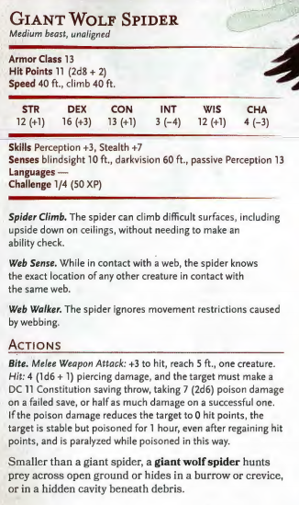

1. Mess hall

Enough tables and place settings for easily 50 men. Cobwebs are thicker here, and sections of the roof have collapsed leaving rubble on the floor and tables/chairs broken. There are metal tankards and broken crockery everywhere. Two golden plates sit alone on the tables.

Covered in acid mold – 1d4 damage for whoever touches them (Nature DC 12 to spot)

5x wrapped food rations that aren’t too mouldy to use

1. 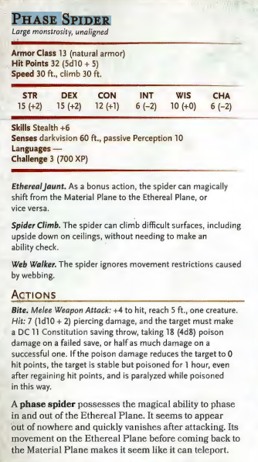Barracks

Door locked, requires picking (or battering)

Very heavily webbed area, as you walk in you see the webs shudder as whatever is inside them retreats away from you. Searching footlockers reveals a whetstone (single use, +2 to damage for edged weapon for 24 hours), 3x bolts of biting and 30gp

DC 14 investigation/perception – a pair of golden knuckledusters (+1 to damage with fist weapons, no effect on AC or attack roll)

Phase spider x1 = 700

1. Kitchen

2 x ettercaps 450 x 2 x 1.5 = 1350

Higher, vaulted ceilings in the kitchen, with a large fireplace at one end. Cauldron on bonfire, full of rotting…something which has long since gone bad. Hooks hanging from the roof would have once held oxen or similar for carving, but now they’re empty except for one, from which is hanging what looks like a fairly recently deceased body.

Investigation DC10 – human, wearing leather armour, with a sigil on his chest (order of neutrality). Cause of death – puncture wounds to abdomen. Partially eaten after death

1. Small room

Smaller room, lower ceiling, rocks are slightly darker here. Heavy metal door. On a metal shelf at the back is a crystal statue, catches the light from inside the kitchen and glints invitingly. Looks expensive.

DC 14 perception – smells of gas, piles of ash in the corners. DC 13 investigation sees pipes and vents in the walls

If PC enters room door slams shut, lever drops over door and room ignites – 2d8+3 fire damage.

Strength check DC 15 to open level and haul door open. Oven fires again on odd numbered turns AFTER door first closes.

1. Empty room

Wooden stairs led 15ft or so down to this room, giving it a total height of 30ft with a high, braced ceiling. The stairs look to have been smashed away hurriedly with a sledgehammer or similar, but you can’t see any evidence of the stairs on the floor below. In fact, the floor is completely empty – no furniture, spiderwebs or even dust that you can see. It is spotless.

On the back wall is a statue of a wizard holding a staff – the magical power of the staff calls out to Patricia and Elsebeth.

1. Guard captain’s office

This seems to have been the office of the castle’s guard captain – there is an overhead map on the area similar to the one you already have on the wall, as well as a now-empty armour stand in the corner. A desk with a battered leather chair sit at the back of the room.

Search room – find heavy steel key in the drawer, as well as useless papers detailing deployment schedules, guard rota etc.

1. Prison

Order of Neutrality:

Dedicated to order of natural world - nothing too good, nothing too evil, complete balance is their aim - essentially order of witch hunters/assassins

"Cohortis et Statera"

Killed Andrei Palovic for being too strong a force of good

Dispatched to kill von Carstein for being too strong a force of evil

Secretive order, noone knows where the orders come from, they are given via dead drop

No extra information - can provide info again from Beregost

Prison - dead goblins - two adventurers in there - also dead spiders - smashed benches, weapon racks cover the floors, clear signs of scuffle

Investigation (DC13) would reveal that it looks like the scuffle took place in the centre of the room

Roof seems to have fallen in exposing bare rock above, stalagmites and stalactites built up - one very large stalactite in centre of room (Roper)

Arrows +1(x3) in ammo stand in corner of room

Half-elf - fine, elven features except badly broken nose - Kirkegaard Windstep - two scimitars, two weapon fighter

Human shou vampire hunter - bald apart from top knot, tattoo around left eye - Jiang Kou - two hand crossbows

Members of Order of Neutrality

Pleading to be let out of cells - darkness came alive and ate the goblin/hobgoblin gaolers

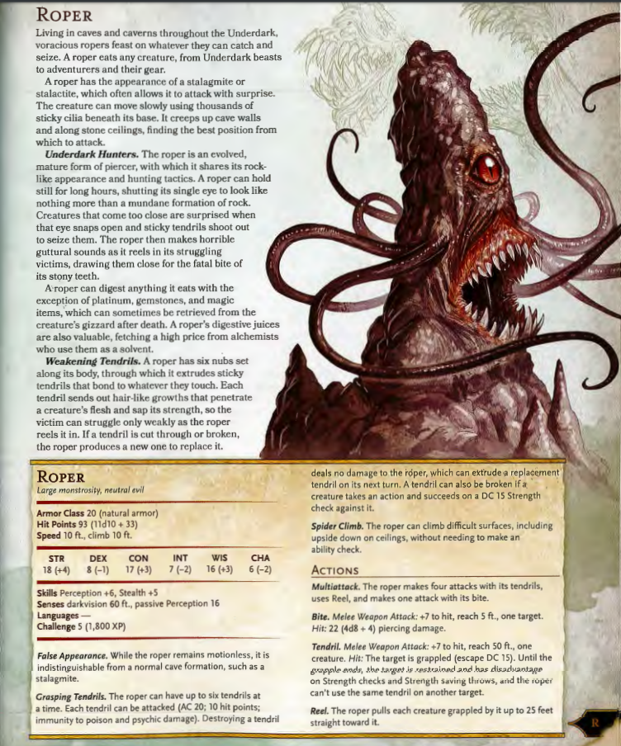Roper -20HP and 2d8+4 damage – remember to go for Jiang/Kirkegaard first

1. Chapel of Bahamut

6x spiders drop from the ceiling as the party enters (300 x 2 = 600)

Clearly a throwback from before the castle fell to the forces of evil, there are several badly damaged pews in rough rows before a raised dais, upon which stands an ornate stone lectern. Behind the lectern is a statue of Bahamut, flanked by two banners – all of which have been badly defiled, with entrails, blood and other substances smeared around them. Impaled upon the statue of Bahamut is a dwarf, dressed in black studded leather armour carrying insignia of Order of Neutrality. His tongue has been cut out and he is clearly dying.

Can administer last rights and/or clean up the statue – Patricia and Jonathan gain inspiration.

Trap on altar – DC 13 perception to notice latch attached to top of lectern. If not disarmed, magic missiles fire from gems set into the corners of room. Inside lectern is a holy tome of Bahamut (which ends up being worthless)

1. Corridor

This corridor seems to have been hurriedly barricaded. The webs are thicker here, and begin to cover the floor (affecting movement). You see bulges and tremors in the webs on the walls and ceiling as whatever is inside them retreats back towards the doorway at the other end of the corridor.

1. Crossroads

Looks to be some sort of guard station, there is a weapon rack and a couple of overturned stools beside a recess in the stone walls. Arrows and weapons

Party is ambushed by 4x grey ooze emerging from cracks in the walls 400 x 2 = 800

1. Laboratory

Door is stuck – needs to be battered open

Clearest room of all for webs – looks like it may have been in use recently. Covered in glassware and full of liquids, stands etc. On one wall is a giant set of shelves filled with heads, arms, legs and organs, all of which seem to be human. They are lit by a sinister green light.

On one of the tables is half a human, appearing to have been stitched together. It is plugged into an odd contraption, a bright light surrounded by spinning bands.

If party approach table the half-thing rears up and attacks – 5hp, AC 10, slam – 1d4 + 2, +3 to attack.

Search room – find magical glyph for door to prison

Potion of insight – INT set to 22 for one minute (6 turns)

Secret door to 15 – DC 13 perception/investigation to notice

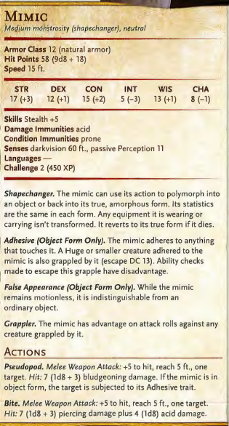

1. Chest room – chest is mimic
2. Torture chamber

Dirtier than most rooms, spiderwebs hang low from the ceiling. Racks, braziers (not burning) and tables full of torture implements. Iron maiden in the corner. Hear sounds of flesh being ripped from a body before you see giant spider crouched low over prey at the end of the room. As you approach it turns and faces you, fangs bared – two smaller spiders emerge from beneath its hairy underbelly

200 + 100 x 1.5 = 450

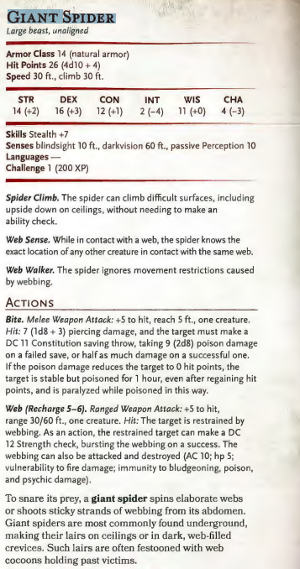

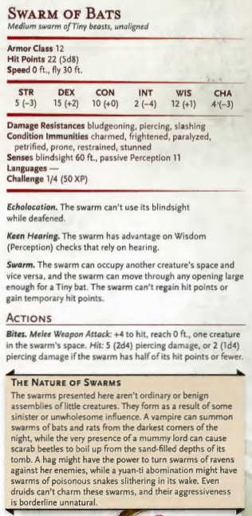

1. Gear room

2 spiders in here but leave without fighting the party (unless shot)

This room has three large gears in the centre of the floor. Inspecting reveals they are held in place by a heavy golden lock, which can be attacked (STR DC 14) to knock it out of the way. If done, the gears clank and spin, opening the door above (but PCs don’t know that yet).

Rooms to the side: Kennels, huntsman/dog handler rooms. 3x arrows +1, 4x bolts of biting, snare.

Useless items: rack of drying ratskins, moleskins and even a bear pelt.

1. Underdark entrance

Webs everywhere, floor falls away into a gaping maw of darkness. Webs on floor, walls, ceilings, festooned with bulging eggs and cocooned victims. Three ettercaps stride between the eggs tending them.

3 x 450 = 1350 x 2 = 1800.

Difficult to search through thick webbing, but DC 18 investigation (DC 13 if webs burnt off) reveals a somehow-unbroken pot holding a potion of cloud giant strength (strength set to 25 for 10 turns)

Underdark:

Humanity’s Sorrow

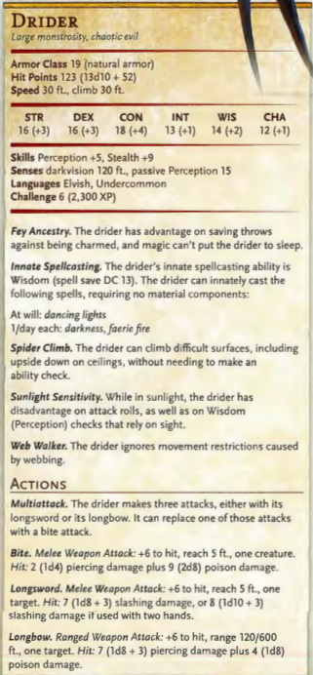Fallen Drow who failed in her promise to Lolth, dark spider goddess. Permanently transformed into elf/spider, now in service of Lolth. Will not fail spider queen again.

Lair is filled with clumps of spiderweb, which will burn if set alight, lighting up the darkness.

Sorrow can hide in the clumps of spiderwebs on the floors, walls and ceiling and is essentially invisible when using them (stealth +9) – loses this bonus if she is not on webbing

Party can burn webs away to remove her cover

Also clusters of eggs in the webbing – if these are attacked HS immediately emerges to defend them regardless of whether she will be in cover or not

Castle encounters

1. Ground floor, main hall

Coalfire braziers line the hallway to give off light, large copper(ish) chandeliers hang from the ceiling. Room is around 40 feet high, chandeliers hang 10ft. Floor would once have been plush red carpet but now is filthy with dirt and grime, and strewn with piles of bones. Around the main pillars you also see multiple corpses slumped against them, and the entire room stinks of death and decay.

Von Carstein stands at one end of the hall, it seems clear he knew of your approach

“You are too late, you cannot defeat me, when my master and I unite I will return him to life and together we will rule this realm. I will be a God, and puny mortals such as you will be unable to stand against me. This has been an entertaining diversion, but now you die”

Von C stays to fight until he takes any form of damage before dimension dooring out

Raises 5 x zombies, 3x skeletons to defend him + 2 animated armour at top of stairs



1. Opulent room mk2 - Much better lit than any other room, this one has been kept largely clear of spiderwebs as well. Large suits of armour on walls holding greatswords. Lush rug covers one side of the room. On a dais in centre of the room, a chest banded with gold sits under a candle chandelier.

Door is mimic.

In chest: 2x potions of healing, 50gp worth of gems etc

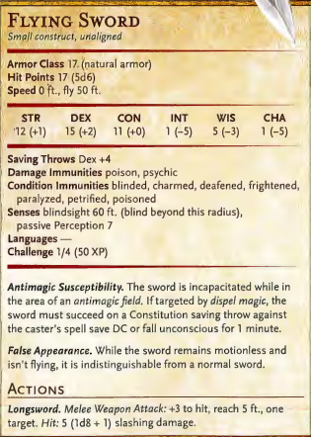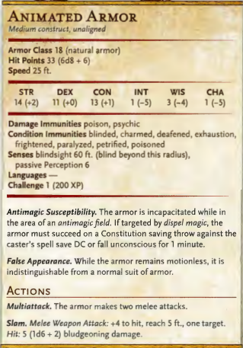2x animated armour, 2x swords, 1x rug = 900 \* 2 = 1800

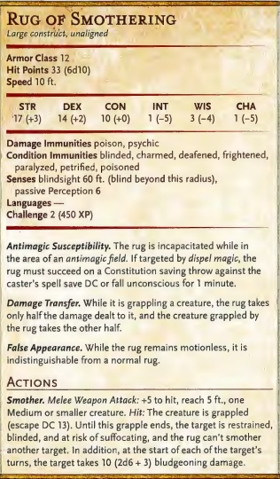



1. Von Carstein 2 – large state dining room by King’s Tower entrance. Large windows at one end. Clearly a storm outside, you can hear thunder and occasional flashes of lightning illuminate the scene. Von Carstein still appears confident, toying with them “Your persistence is… vexing. No matter. We shall see how you fare as you face your old allies! Come my pretties, have at them ”

Notice four large shapes moving on all fours from the darkness in corners of room. Four large zombie bears roll forward, flesh stripped back from their teeth, gaping holes in their flanks where they have been pierced by spears. Large, milky, unseeing eyes roll in their heads, fur matted with blood. As he strides from the room VC clicks his fingers and the chandeliers and torches lining the walls illuminate and you see clearly that these are your four previous companions, Yogi, Booboo, Pugsy and He Who Shan’t be Named. The bears, intent on nothing but killing, surge forward.

1. Statue room – large statue of golem – you recognise to be flesh golem. Door swings shut behind you. You hear cogs and gears begin to turn and a mechanical timer begins counting down from 20. The golem holds in its hands a cube of stone with what is clearly a large red wooden button set into it. Party must let timer run out to open door.

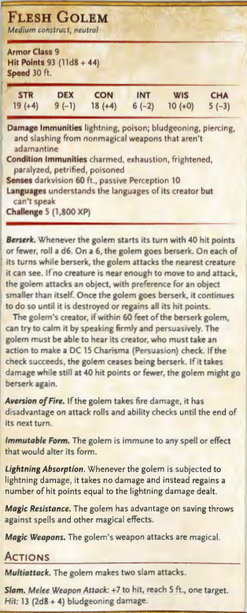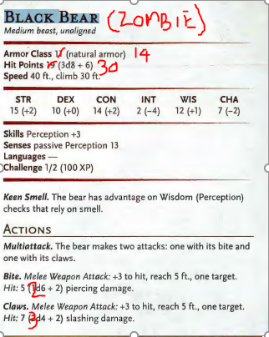

1. Antechamber, floor below King’s Tower. Plush, ornate. Four pillars in room. DC 15 Perception (or directed looking) to see five glass orbs (AC 10, 1HP) dotted around the room. Two more hidden in corners or held by statues (DC 18 or directed looking). If all 7 are destroyed golem becomes inactive.

At beginning of combat VC – “you WILL leave now! You will not distract me from my quest! Once I find the tomb my master will rise again and my transformation will be complete!

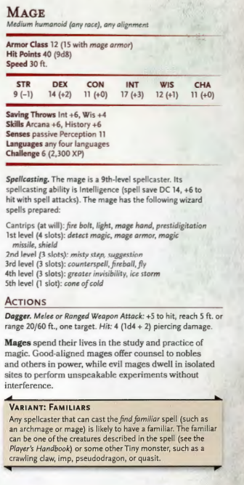

Note: use spellbook, not spells above

Come across von Carstein in Kings’ Tower – large laboratory/living chamber. Can hear rain lashing the windows and roof, along with the sounds of frenzied squeaking and thumps as a huge swarm of bats swirls around the tower. Von Carstein scrabbling in his desk, gathering what papers he can carry. As you approach he makes a motion with his hand and a field of magical energy bisects the room, with you on one side and him on the other. ‘fools! You do not know the power you are dealing with! If not I, the Lich King Ner’zhul will consume your souls! I must find his tomb! It is here, beneath Beregost! He wills me to do so and restore him to his former glory! Maggots such as you will not distract me from my task!”

Blows back off tower, rain streaks in, bats swarm around the tower and through the hole. VC runs and leaps out into the open air, only to land on some sort of invisible platform that quickly bears him to the ground and out of sight. The forcefield disappears and you feel magic go with it, entire tower quakes ominously.

Tower then collapses in stages, party need to run!

Final fight:

Tower crash lands in graveyard, VC continues to taunt/enrage party as he engages them directly with magic. Bats continue to swarm around the battlefield and overhead, creating a barrier of sorts around the graveyard

VC: swarm of bats – VC points at creature and bats swarm around, biting and blinding target. Refresh 6 +. Target makes DEX save (13+) to avoid – or else 1d8 damage and disadvantage on all combat rolls until end of next turn.

On death:

No! My master! I have failed you! Forgive me… I was not strong enough… You! Mortals! Enjoy your last breaths on this plane, Ner’zhul comes for you! \*urgh\*\*bats disperse\*

Moment of silence as VC slumps to the floor. Suddenly, with a roar of rage, his body is jerked back to a standing position, apparently by invisible strings. VCs eyes are blank and his mouth hangs limply, whilst a booming voice emanates from it.

“FOOLS. DO YOU NOT SEE THAT YOU SIMPLY DELAY THE INEVITABLE? MY POWER RETURNS, AND ONCE I AM RISEN YOU WILL BE THE LAST TO DIE. YOU WILL WITNESS THE SUBJUGATION OF YOUR RACES, THE DEATHS OF YOUR PEOPLE AND THE SCOURING OF YOUR LANDS. I WILL SAVOUR YOUR DESCENT INTO INSANITY”

And with that the force withdraws from VCs body and it drops to the floor again, this time disintegrating into a fine black dust.

As VC expires, rain stops as suddenly as it began. Immediately the cloud cover seems to lift slightly and rays of sunshine pierce through the gloom. The longer you stand and wait, the gloom begins to lift entirely and on the horizon large shafts of sunlight bathe the hills. Around your feet green shoots begin to thrust their way through the blackened earth, clearly being held back by the destructive magical presence of VC before now.

You have triumphed over these forces of evil, vanquished the undead threat and made Beregost safe again – at least for now.

Epilogue:

Travel back to Beregost

Aleksandr Trevia imprisoned

Feltast put out warrant for party – dismisses out of hand stories of lich lair beneath Beregost. Party are stripped of weapons and thrown in prison as well, with an execution date to be set